A2: Project Plan – Dave Meyer
A Written Assignment consisting of a theoretical review, analysis and feedback of a case study, accompanied by a practical detailed development (for linear projects) or pre-production (for non-linear) budget containing a visually designed overview, above the line summary and below the line items (2-3 pages) is required. Your practical use of Excel or other industry standard budgeting software and involvement in team discussion, independent research and composition will be required. You will need to showcase this completed artefact as part of your online portfolio.

Hello everyone!
Today I will talk about the project plan and budget for my game Synergy. I already talked about my production plan in A3, which already contains most of the project planning and review of the development, so instead of talking about this again, I will focus almost completely on the Budget Plan of Synergy.
When I was at the point where I was done writing down what I needed for game production and development, I needed to look into the budget. Here, I was surprized to see, how much money you need even for an indie type game development.
I opened up another excel sheet and wrote down every profession with additional hourly salary, fix costs, price for equipment and other costs. Obviously, I will take over most of the jobs myself as well, but it is always good to see the maximum cost your business could need.
These costs are:
- Programming 35$/h Working for 1440 hours 400$ fix = 51800$ Annually (www.payscale.com, 2022d)
- Level Designing 32$/h Working for 640 hours 100$ fix
= 21580$ Annually (www.payscale.com, 2023b)
- Producing I put this job onto myself
= 10000$ Annually
- Sound FX 34$/h Working for 80 hours 100$ fix
= 3320$ Annually (www.payscale.com, 2022b)
- Music Composition 25$/h Working for 180 hours 100$ fix
= 5100$ Annually (www.payscale.com, 2022c)
- Animator 30$/h Working for 420 hours 100$ fix
= 13700$ Annually (Payscale.com, 2022)
- Business Manager 30$/h Working for 480 hours 100$ fix
= 14800$ Annually (www.payscale.com, 2023a)
- Costs for legal advice 40$/h Working for 20 hours ---
= 800$
- Game testing 15$/h Working for 180 hours ---
= 6700$ (www.payscale.com, 2022a)
- Marketing --- --- ---
= 4000$
= 131800$
These costs are rounded and shouldn’t be looked at as real numbers, I used average salaries for all of the statistics above. As I said as well, it is pretty uncommon to outsource all of the work to employees when creating an indie game like this.
You can find the Excel Sheet for the Budget Plan of Synergy here: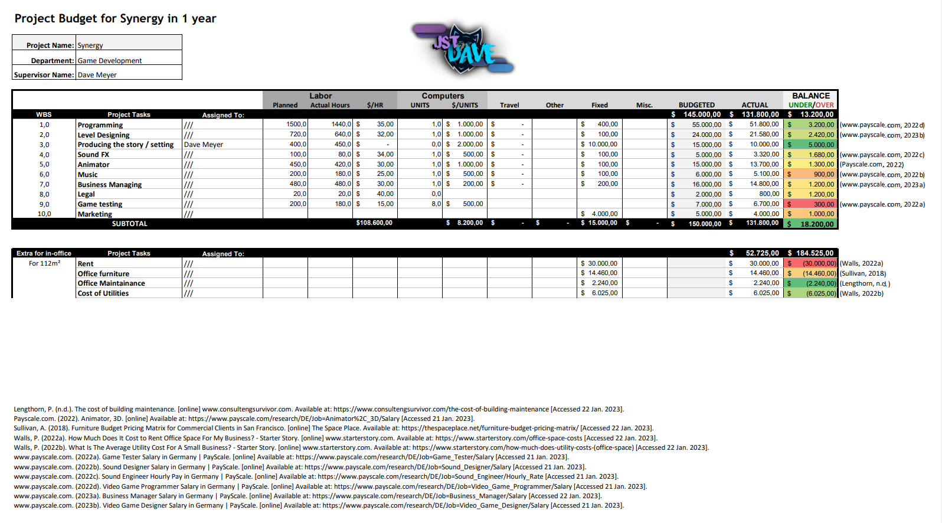
As you can see under the salary and cost overview, I have looked into the difference of working from an office and working from home to see which amount of costs we would safe annually from only offering Home-Office Jobs.
With a rent of 30000$ (Walls, 2022a), Office furniture of 14400$ (Sullivan, 2018), Maintenance of 2240$ (Lengthorn, n.d.) and cost of utilities of 6025$ (Walls, 2022b) annually, we would safe over 30% of costs if we work on the game from home instead of in an office. Saying this, I instantly decided that we only offer home office jobs for the development of Synergy.
You can find additional information about the project and budget plan as well as every other part of the game on my website under https://jstdave.com/synergy.
I hope you enjoyed reading through the project and budget plan!
Best regards, Dave Meyer.

Citations:
www.payscale.com. (2023b). Video Game Designer Salary in Germany | PayScale. [online] Available at: https://www.payscale.com/research/DE/Job=Video_Game_Designer/Salary [Accessed 21 Jan. 2023].
www.payscale.com. (2023a). Business Manager Salary in Germany | PayScale. [online] Available at: https://www.payscale.com/research/DE/Job=Business_Manager/Salary [Accessed 22 Jan. 2023].
www.payscale.com. (2022d). Video Game Programmer Salary in Germany | PayScale. [online] Available at: https://www.payscale.com/research/DE/Job=Video_Game_Programmer/Salary [Accessed 21 Jan. 2023].
www.payscale.com. (2022c). Sound Engineer Hourly Pay in Germany | PayScale. [online] Available at: https://www.payscale.com/research/DE/Job=Sound_Engineer/Hourly_Rate [Accessed 21 Jan. 2023].
www.payscale.com. (2022b). Sound Designer Salary in Germany | PayScale. [online] Available at: https://www.payscale.com/research/DE/Job=Sound_Designer/Salary [Accessed 21 Jan. 2023].
www.payscale.com. (2022a). Game Tester Salary in Germany | PayScale. [online] Available at: https://www.payscale.com/research/DE/Job=Game_Tester/Salary [Accessed 21 Jan. 2023].
Sullivan, A. (2018). Furniture Budget Pricing Matrix for Commercial Clients in San Francisco. [online] The Space Place. Available at: https://thespaceplace.net/furniture-budget-pricing-matrix/ [Accessed 22 Jan. 2023].
Payscale.com. (2022). Animator, 3D. [online] Available at: https://www.payscale.com/research/DE/Job=Animator%2C_3D/Salary [Accessed 21 Jan. 2023].
Lengthorn, P. (n.d.). The cost of building maintenance. [online] www.consultengsurvivor.com. Available at: https://www.consultengsurvivor.com/the-cost-of-building-maintenance [Accessed 22 Jan. 2023].

