A3: Production Schedule – Dave Meyer
A Written Assignment consisting of a theoretical review, analysis, and feedback of a case study, accompanied by a practical detailed development (for linear projects) or pre-production (for non-linear) schedule in 3 parts, containing a visual calendar overview, top line summary and detailed weekly breakdown of dates and deliverables (3-4 pages) is required. Your practical use of Excel or other industry standard budgeting software and involvement in team discussion, independent research and composition will be required. You will need to showcase this completed artefact as part of your online portfolio.

Hello everyone!
Today I will talk about the production schedule of my game Synergy. I will attach useful graphics and diagrams to make it more easy for you to understand the exact details of said production plan.
First of all, I started thinking about the possible parts that are most important for the production of the game. I put those inside of a list and worked on figuring out the details of the exact production and which sub-categories are needed to find a production plan with the highest success rate.
The most important parts are:
- Story and setting
- Production (Level Design, Programming)
- Music and Animation
- Testing, Marketing and Reviewing
With the sub-categories:
- Story and setting
- Looking for inspiration
- Finding the genre
- Scripting the story
- Making Sketches
- Making Mechanics
- Production
- Level Design Planning
- Programming Planning
- Level Design Production Phase
- Programming Production Phase
- Check & Correction of Level Design
- Check & Correction of Programming
- Music and Animation
- Figure out the right vibe / mood for sounds
- Figure out the right vibe / mood for music
- Compose Music
- Make Sound-Design
- Check & Correction of Music
- Check & Correction of Sound-Design
- Testing, Marketing and Reviewing
- Make sure the game is suitable for the market and all countries of distribution
- Let people Playtest the game
- Market the game
- Make finishing touches / get rid of bugs, errors, etc.
- Review finished game
Before putting all of these into a combined sheet, I looked at how long I would possibly need to finish every single category. For this, I looked at normal production times and implementations of possible game features.
Key points for Level Designing:
- Hallway with information and Portal into Overworld
- At least 3 Overworld levels with puzzles to get further through the story
- Easter Eggs and Story segments for every Overworld part
- ~5 escape rooms per Overworld with additional puzzles and cubes hidden inside of the room
- Additional optional levels and props
Key points for Programming:
- Inventory System with Storyline, Cubes and other items
- Puzzle system for cubes and escape rooms
- Portal system for traveling across Overworlds and Escape Rooms
- Menu for game (Main Menu, Options, etc.)
- Different game modes (Stopwatch Mode, Competitive Mode)
- possible randomization of Escape Rooms and Overworld Levels for custom player experience
Key points for Music / Sounds:
- Different music for Main Menu, Overworlds, Escape Rooms
- Fitting the music to the genre of the current Overworld and Escape Room Theme
- Building Sound effects for game actions
- Building Music for the cutscenes of the game
Key Points for Animation:
- Character Animations (Walk, Run, Sneak, Jump, Holding cubes, grabbing items, etc.)
- Cutscene Animations for Story Mode
- Animations for puzzles
- Portal Animations / Object Animations
Key points for Marketing:
- Put gameplay trailers, gameplay, cutscenes onto social media
- Get a ~release date for the game so people can remember
- Build Pages for Steam, Epic Games, GOG, etc. for people to add to the wish list and remember
- Have a pre order bonus for people to order the game before launch
Key points for Reviewing:
- Be sure that all bugs, errors and flaws are mostly gone until launch or Early Access
- Get people from the outside to look at your game in detail to find mistakes
I put all of the categories and sub-categories into one sheet and put them into a week forecast to see around when these categories should be finished inside of our schedule.
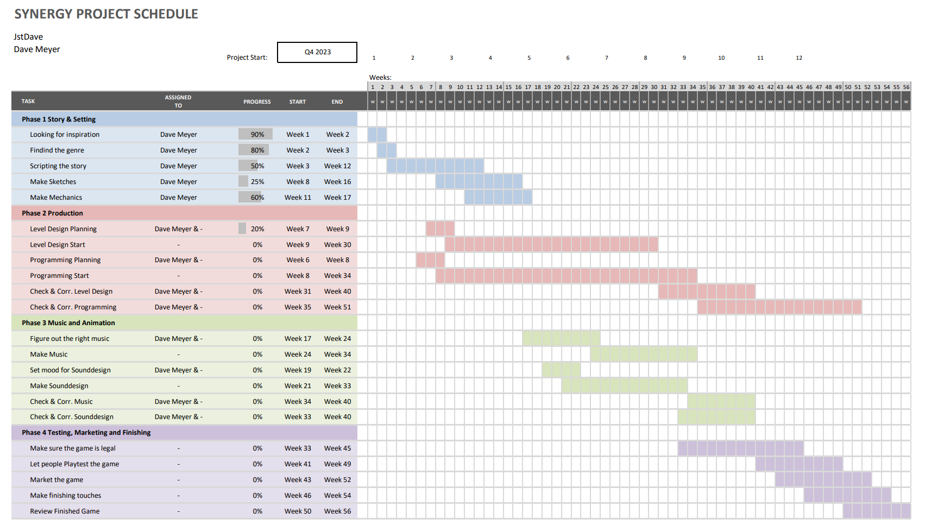

After I have made this, I decided to make a production plan that is more suitable for marketing purposes to show the team and the world what our main schedule is.
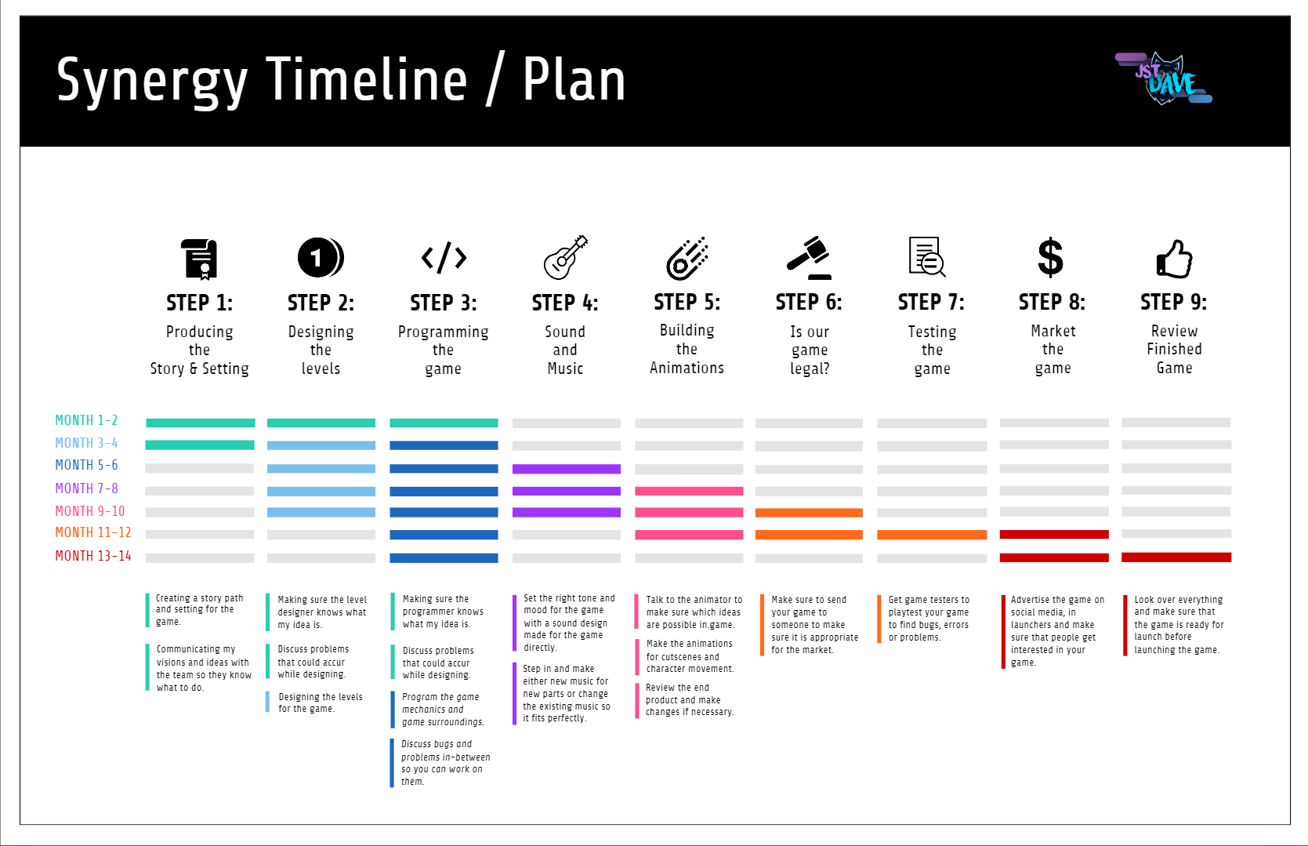
With this gathered information we should be good to develop and launch our game without big problems coming our way, hopefully.
You can find additional information about the production plan as well as every other part of the game on my website under https://jstdave.com/synergy.
I hope you enjoyed reading through the production plan!
Best regards, Dave Meyer.

